*This assignment has 3 parts. Return your assignment (via Canvas, by the posted due date) in the form of a Word document (including all answers, figures, and R script).*

*Guidelines for homework document:*

* *Include your name at the top of the document*
* *Include the course, lab number, and date at the top of the document*
* *Number and label the questions and answers clearly! (We should easily be able to find your answers!)*
* *Include all of the requested output (e.g., values, data tables, and plots), not just the code for them. (We will not copy your code into R to see if it works).*
* ***Include informative, numbered captions for figures and tables.***
* *Submit a Word (or PDF) document (no .r or .pages files please).*
* *Include all your code used for the problems.*
* ***Answer ALL questions using complete sentences that are clear and informative****.*

**A. Exponential Growth (4 pts)**

The exponential growth model takes the form:

$$N_{t}=N_{0}e^{rt}$$

Where Nt is the number at time t, N0 is the initial population size, and r is the intrinsic rate of increase (with units of: individuals / (individual*year)). The doubling time of a population can be calculated as:

$$t_{double}=\ln\left(2\right)/r$$

1. What are the doubling times for 2 populations if r = 0.1 and 0.2? Would the doubling time change if the population started with a different N0? What does that mean about what drives the doubling time for a population? (2 pts) [*psst: don’t forget complete sentences for all answers…*]
2. In your own words and in a few sentences, explain what the exponential growth model is (and its key ideas) as if you were talking to your parents. (2 pts)

**B. Exponential mortality (14 pts)**

The exponential mortality model is one of the most-used models in fisheries science and is the basis for many age-structured population models. It takes the form:

$$N_{t}=N_{0}e^{-Zt}$$

Where **Z is the instantaneous mortality rate**.

1. Plot out the population trajectory for ten years for the following six scenarios, Z = {0.05, 0.1, 0.2, 1.0, 2.0, 3.0}, assuming thzat the initial population size is 100. Have all of your trajectories plotted on the same graph (with N as the Y-axis and time as the X-axis), and include a legend. Briefly describe how the value of Z (and its sign) affects the shape of the curve. (4 pts)
   1. (HINTS: I recommend the “brute force” method, where you generate a different object for each scenario. For example, create an object called N_0.05 for the Z=0.05 scenario, an object called N_0.1 for the Z=0.1 scenario, etc. Once you have those calculated, you can add them to a plot using the lines() function, as we did in lab, but pick different colors.)
   2. Reminder: make sure to include a figure caption for your figure. Also, adjust the figure so that the legend doesn’t cover the lines (often, all this takes is resizing the plot window in RStudio and replotting your figure).
2. The half-life (**thalf**) of a cohort or population is often a metric that is of interest, and it is defined as the time it takes for half of the population to be lost. Derive the equation for **thalf** using the exponential mortality model as your starting point. Show your work. (2 pts)
3. Using the half-life equation, calculate the half life for each of the six Z scenarios from question number 3. Report the values here and explain the patterns you see. (2 pts)

The instantaneous mortality rate Z can be hard to wrap your head around, and expressing this mortality rate as an **annual mortality rate (A)** is often very helpful. For example, if A=0.2, that means that 20% of the population is dying each year. Convert between the two rates using these equations:

$$A=1-e^{-Z}$$

$$Z=-ln⁡(1-A)$$

1. Answer the following questions:
   1. Calculate and report the annual mortality rate (A) if Z=0.2 and if Z=1.0. (2 pts)
   2. Below is a plot of A vs. Z for the six scenarios in question 3. Use the plot to describe how the annual mortality rates compare to instantaneous mortality rates. For example, is the magnitude of A always smaller or larger than Z? Are there any constraints on the value of A? At what values are A and Z relatively similar? Etc. (2 pts)
   3. Write some R code that will produce a figure that looks like the one below. It doesn’t have to be identical, but should be very similar. (2 pts)

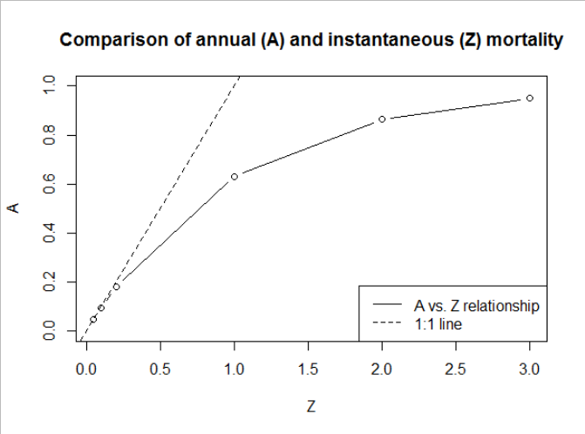A

**C. Human Population Growth Exercise (6 pts)**

In lab, we did an in-class exercise using the file “**Lab 02 - Exercise_HumanPopGrowth.xlsx**”, in which we crudely fit an exponential growth model and a logistic growth model to human population data from 1950-2016. Please answer the following questions based on that exercise.

1. Paste the figure you developed with your best fit you were able to obtain through trial and error. Don’t forget to include your caption. (2 pts)
2. [***Short essay (4-8 sentences)***] On the “forHW” tab of the file, there is a graph (copied below) and some text. How does this graph and the observed trends relate to the exponential and logistic growth models that we've been discussing? For example, what would this plot look like if the population were growing exponentially and why? What would this plot look like if a population were growing logistically and why? What does this tell us about how the human population has been growing, and why might that be? (4 pts)
3. How many hours did you spend on completing this entire homework? 2.5 hr so far
4. Work in a group for at least part of the homework (or to confirm answers) and include a picture of you doing it (e.g., meeting in person or on zoom, Facetiming, exchanging emails, etc). (+1 extra credit)

